Download, Install and Load a package in R using the packages Menu Tab – (Install package(s) Local Disk)
As an example: Downloading, installing and loading the IPSUR package
Step 1: In order to download a Package from R
Enter “r-project.org” in your desired browser as seen below:
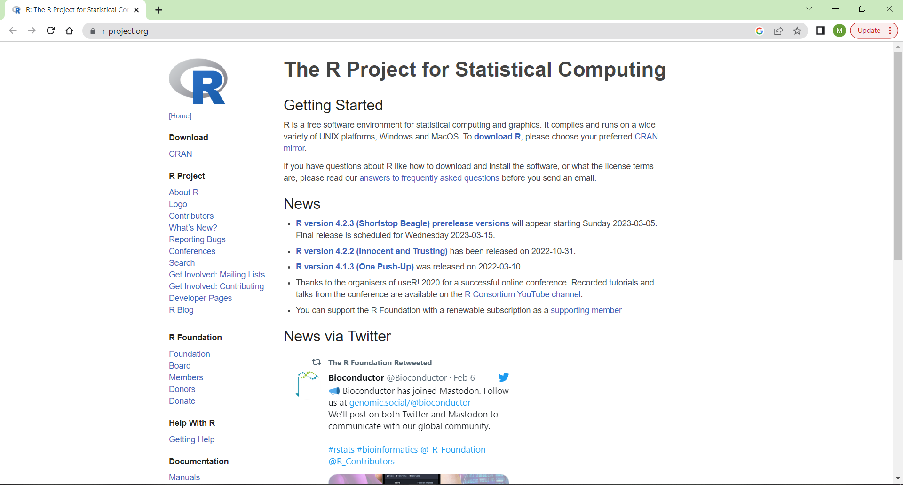
Step2: Click on the CRAN as shown above then click on 0-Cloud on the next Page as seen below:
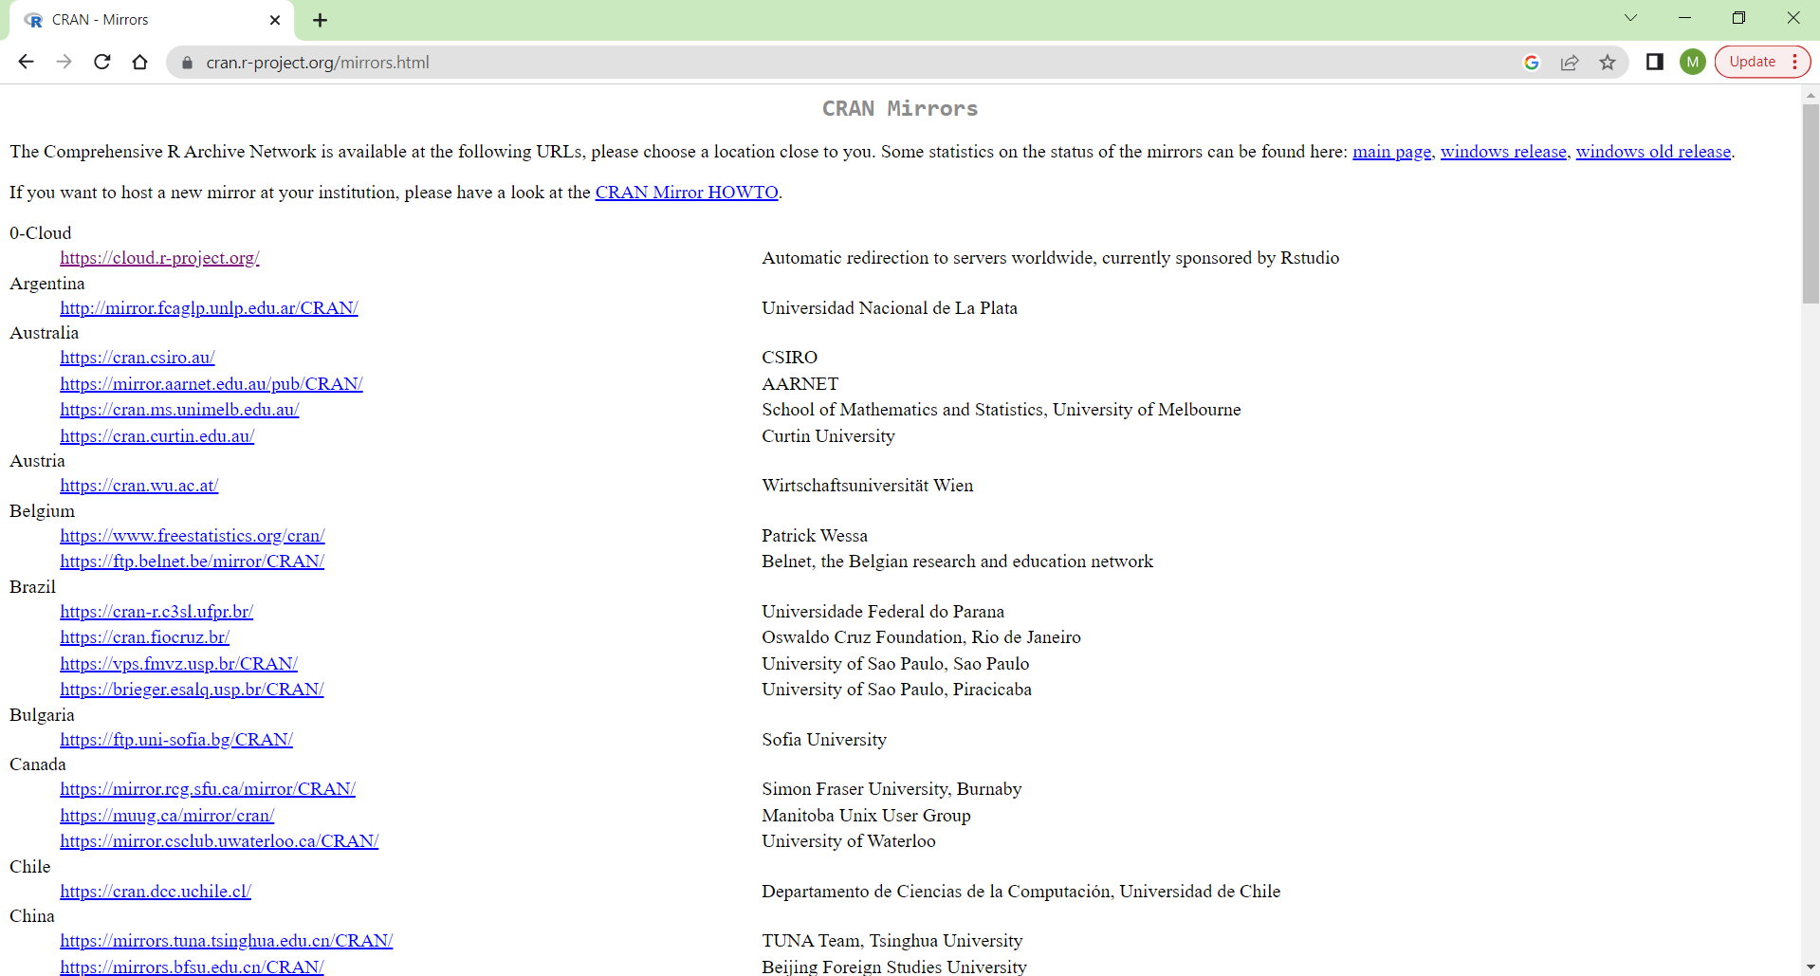

Step 3: Click on the Packages link under the Software Heading on the Left-Hand side of the page as seen below:
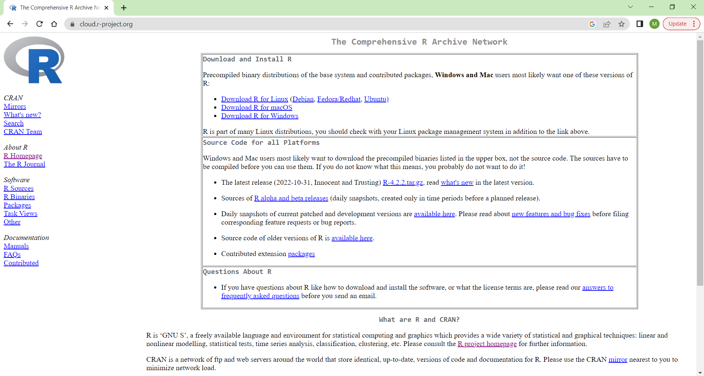
Step 4: You will be directed to the next page, you need to scroll down to locate the related directories and click on “bin/windows/contrib”.
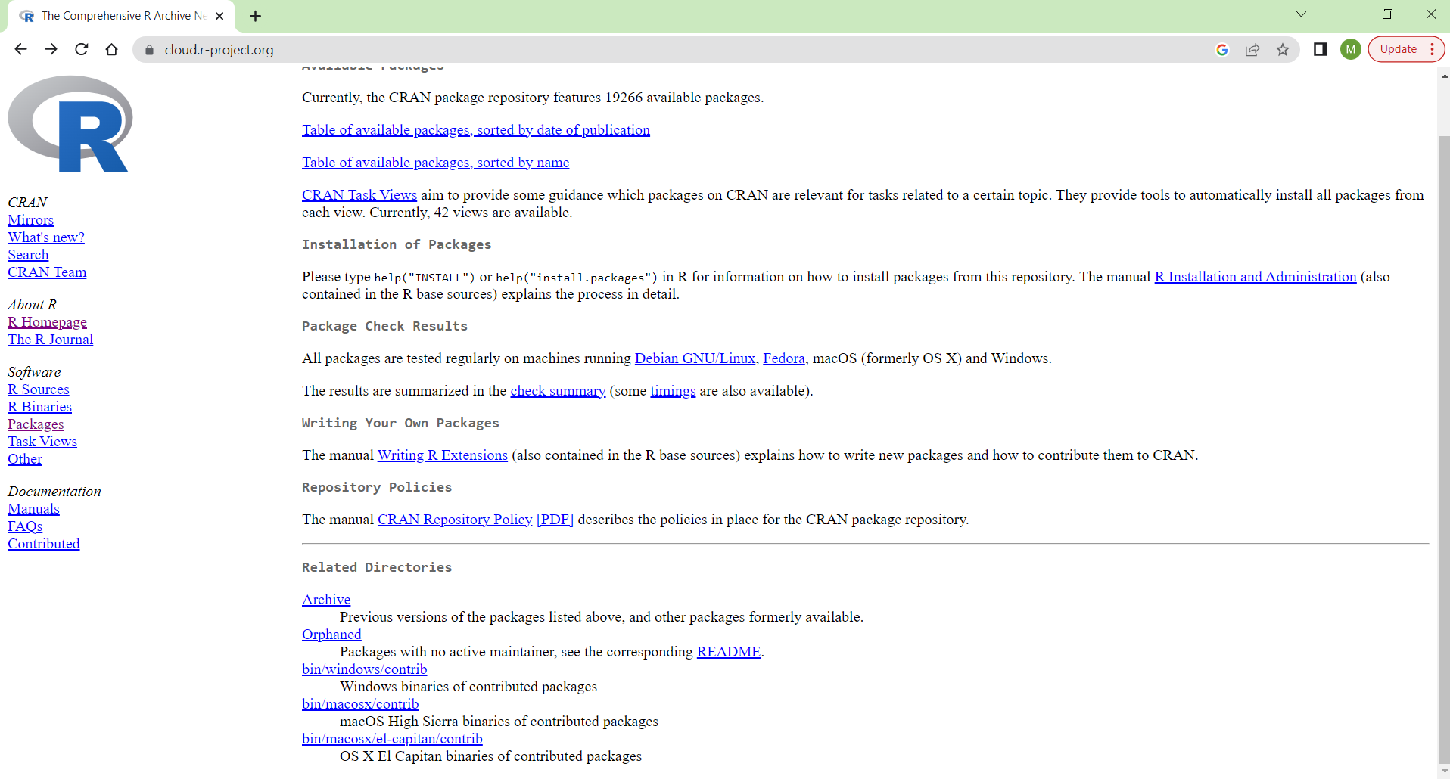

Step 5: You would need to select the version 4.5.1 – as we are using the r version 4.5.1 in practical’s.
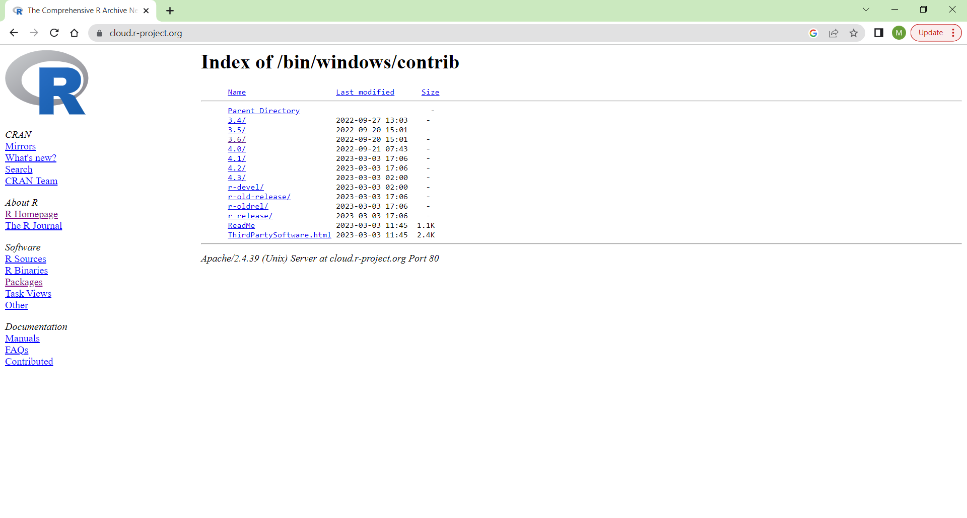
Step 6: within the next page below in order to locate the package we need to download would be by pressing CRTL + F in order to open a search bar – then enter “IPSUR” in the search bara and press enter. It should locate the Package that we would need to download. Click on the package to download it.
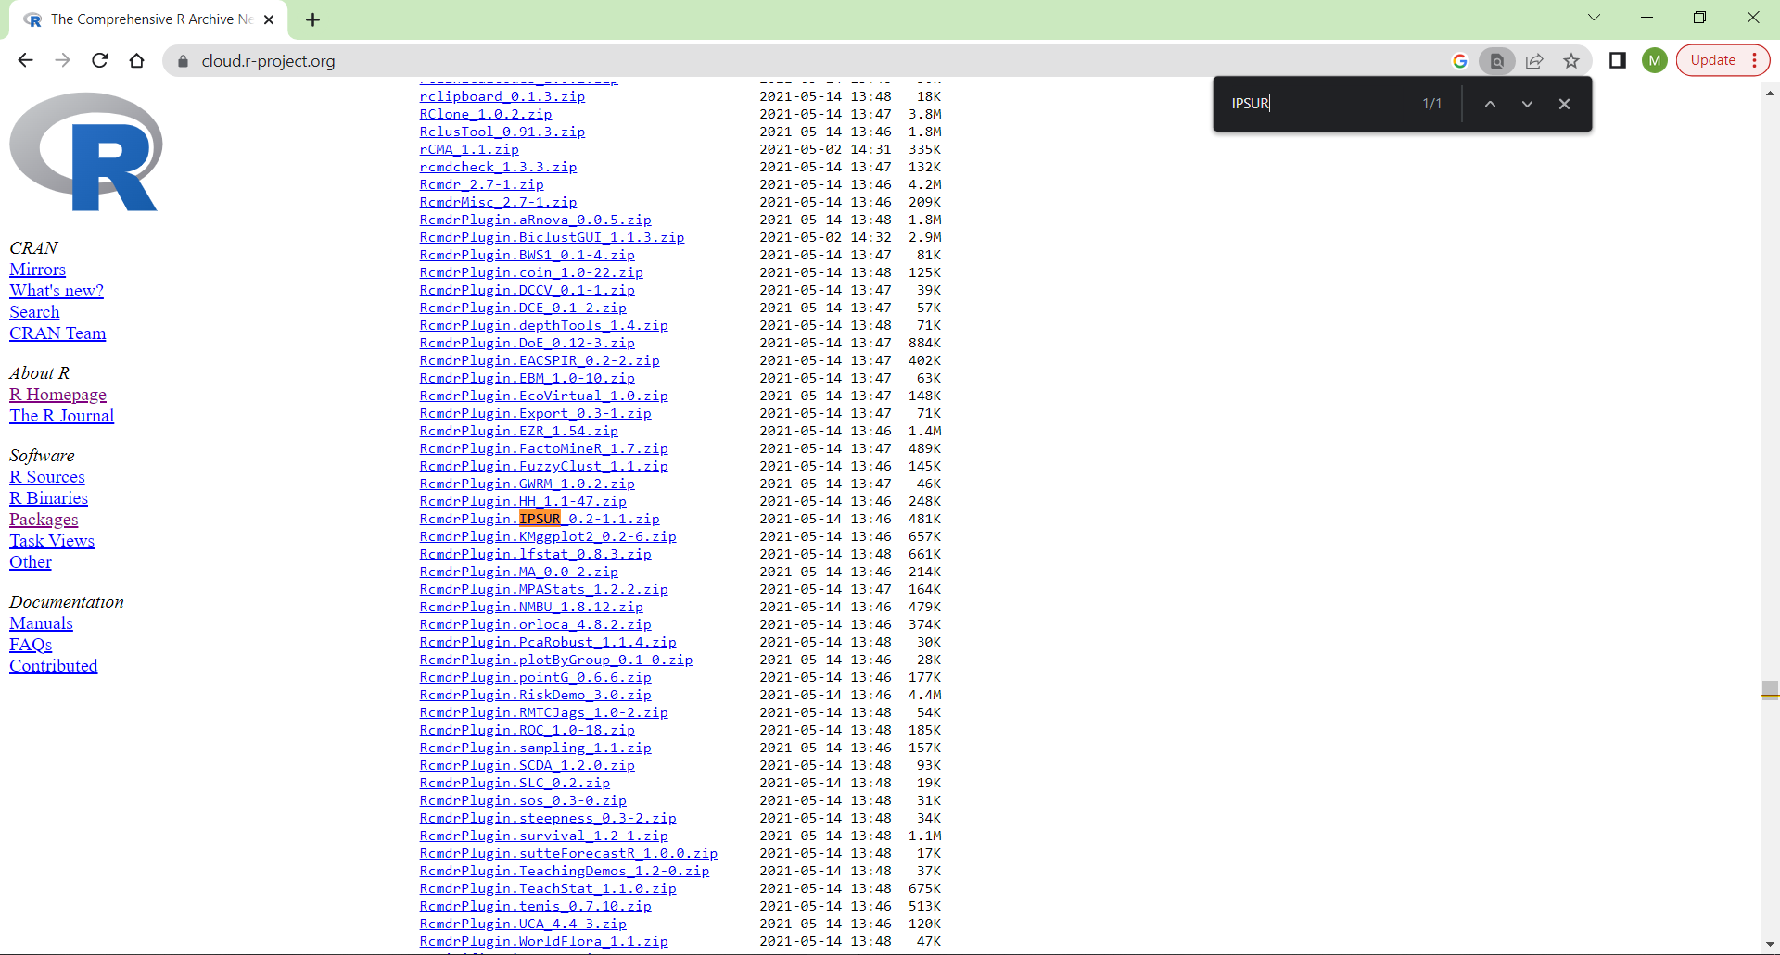

Step 7: The package should be downloaded as seen below and it would be located in your downloads folder.

Step 8: Open r version 3.6.3 and click on the packages menu tab and then the Install package (s) from local disk and select your IPSUR package that you have downloaded.
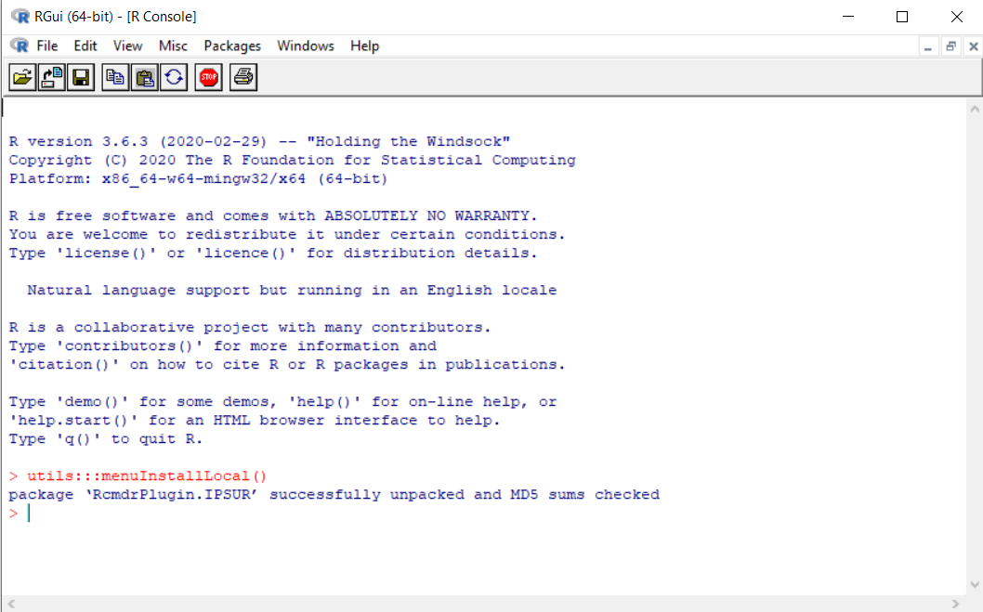
Step 9: Now you have to load your package by using the library function.